**Ideation Phase**

**Define the Problem Statements**

|  |  |
| --- | --- |
| Date | 20 June 2025 |
| Team ID | LTVIP2025TMID48627 |
| Project Name | Measuring the pulse of prosperity: an index of economic freedom |
| Maximum Marks | 2 Marks |

**Customer Problem Statement Template:**

Create a problem statement to understand your customer's point of view. The Customer Problem Statement template helps you focus on what matters to create experiences people will love.

A well-articulated customer problem statement allows you and your team to find the ideal solution for the challenges your customers face. Throughout the process, you’ll also be able to empathize with your customers, which helps you better understand how they perceive your product or service.

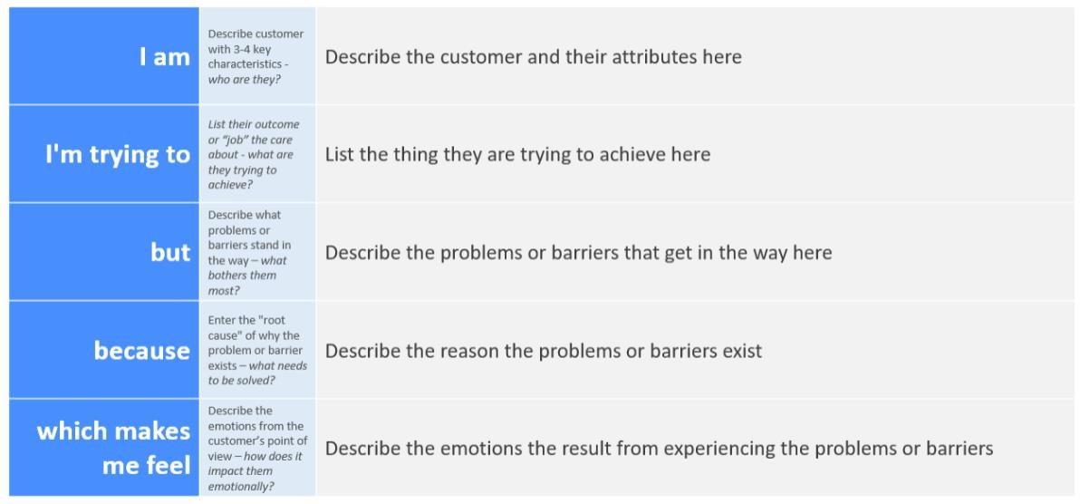

Reference: <https://miro.com/templates/customer-problem-statement/>

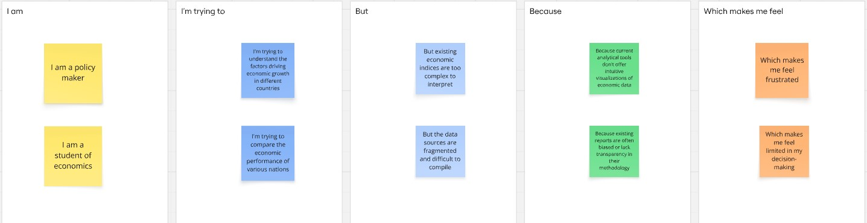

|  |  |  |  |  |  |
| --- | --- | --- | --- | --- | --- |
| **Problem**  **Statement (PS)** | **I am**  **(Customer)** | **I’m trying to** | **But** | **Because** | **Which makes me**  **feel** |
| PS-1 | a policymaker | understand the drivers of economic prosperity in different nations to formulate effective policies. | existing economic  indices are often too complex, lack timely updates. | there's a need for a comprehensive, easily digestible, and regularly updated index that integrates various dimensions of economic freedom. | frustrated and uncertain about the optimal policy choices. |
| PS-2 | an economic researcher | identify clear correlations between economic freedom and socioeconomic outcomes for academic analysis. | current data sources are fragmented, inconsistent, and difficult to compare across different countries and time periods. | there isn't a standardized, reliable, and easily accessible dataset that combines diverse  indicators of economic freedom with relevant outcome variables. | overwhelmed by data collection and analysis, and limited in drawing robust conclusions. |

2.2 Empathy map

